

**DOSSIER**

**Supplemental Material – Intern Team Alpha**

**6 August 2014**

Table of Contents

Presentation 1

Financial Tables 21

**P&L 21**

**Assumptions: 2014 22**

**Assumptions: 2015 23**

**Assumptions: 2016 24**

**Assumptions: 2017 25**

Middle East Internet Penetration 26

# Presentation

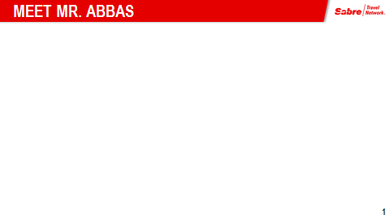

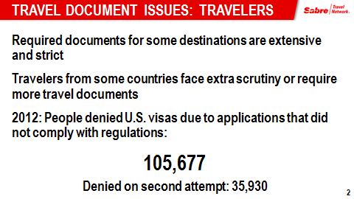

PRESO PAGES

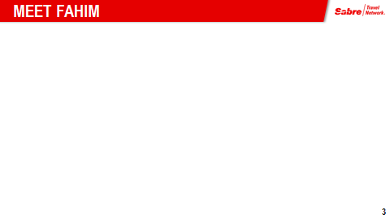

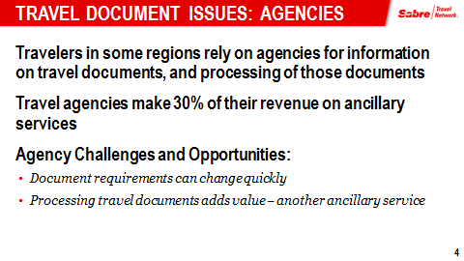

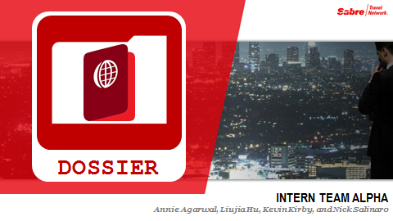

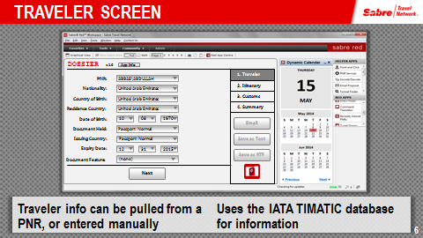

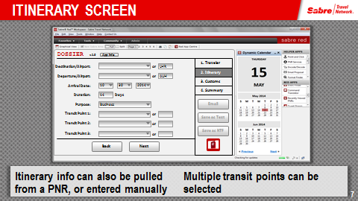

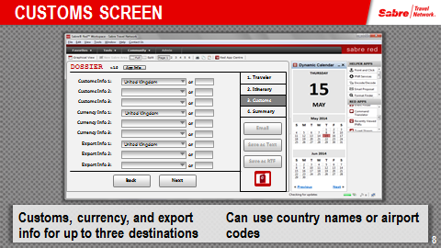

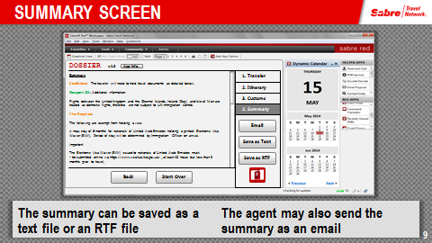

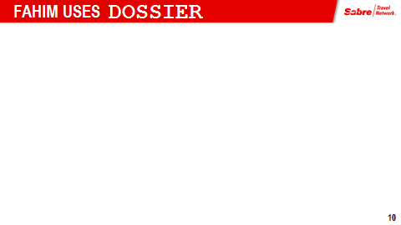

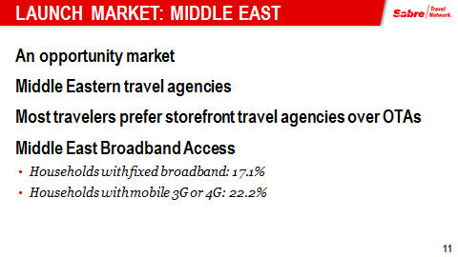

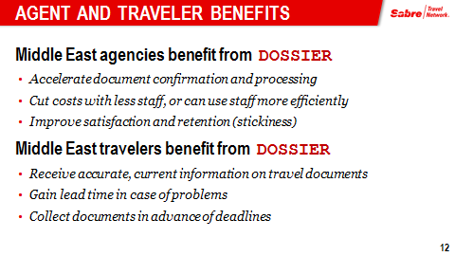

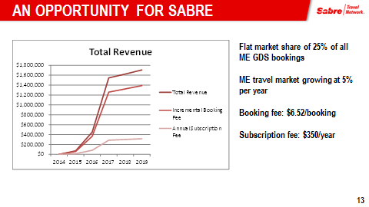

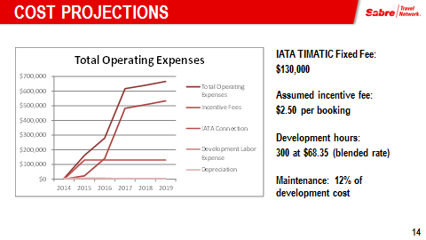

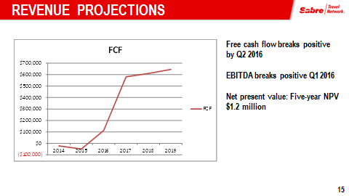

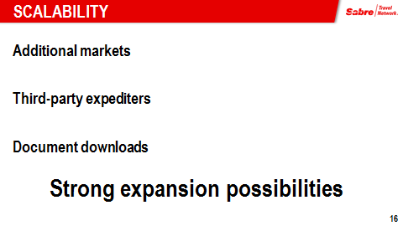

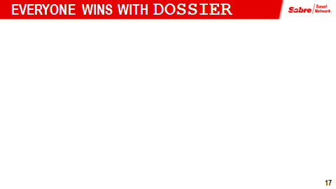

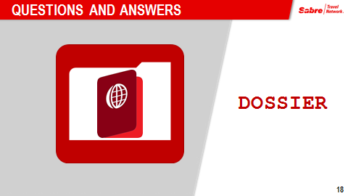

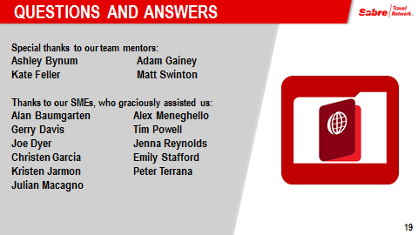

# Financial Tables

## P&L

|  |  |  |  |  |  |  |  |
| --- | --- | --- | --- | --- | --- | --- | --- |
| **Year** |  | **2014** | **2015** | **2016** | **2017** | **2018** | **2019** |
| **Drivers** |  |  |  |  |  |  |  |
| Middle East Travel Agents |  | - | 38 | 239 | 819 | 861 | 905 |
| Incremental Bookings |  | - | 2,271 | 14,322 | 49,169 | 51,673 | 54,306 |
| **Revenue** |  |  |  |  |  |  |  |
| Annual Subscription Fee | $350 | - | $13,249 | $83,545 | $286,817 | $301,429 | $316,785 |
| Incremental Booking Fee | $6.52 | - | $58,147 | $366,657 | $1,258,765 | $1,322,893 | $1,390,288 |
| **Total Revenue** |  | **-** | **$71,396** | **$450,202** | **$1,545,581** | **$1,624,322** | **$1,707,073** |
| **Expenses** |  |  |  |  |  |  |  |
| Development |  | $820 | - | - | - | - | - |
| Maintenance |  | - | $2,559 | $2,661 | $2,699 | $2,807 | $2,919 |
| **Development Labor Expense** |  | **$820** | **$2,559** | **$2,661** | **$2,699** | **$2,807** | **$2,919** |
| IATA Connection |  | - | $130,000 | $130,000 | $130,000 | $130,000 | $130,000 |
| Incentive Fees | $2.50 | - | $22,296 | $140,589 | $482,655 | $507,244 | $533,086 |
| Depreciation |  | $4,921 | $6,562 | $6,562 | $1,640 | - | - |
| **Total Operating Expenses** |  | **$5,741** | **$161,416** | **$279,812** | **$616,994** | **$640,051** | **$666,005** |
| **Operating Income** |  | **$(5,741)** | **$(90,020)** | **$170,389** | **$928,587** | **$984,271** | **$1,041,068** |
| **EBITDA** |  | **$(820)** | **$(83,458)** | **$176,951** | **$930,227** | **$984,271** | **$1,041,068** |
| *EBITDA Margin* |  | *0%* | *-117%* | *39%* | *60%* | *61%* | *61%* |
| **Cash Flows** |  |  |  |  |  |  |  |
| Taxes |  | $(2,182) | $(34,208) | $64,748 | $352,863 | $374,023 | 395,606 |
| **Net Income** |  | **$(3,560)** | **$(55,812)** | **$105,641** | **$575,724** | **$610,248** | **645,462** |
| **D&A** |  | $1,640 | $6,562 | $6,562 | $4,921 | - | - |
| **Capex** |  |  |  |  |  |  |  |
| Development |  | $19,685 | - | - | - | - | - |
| **Total Capex** |  | **$19,685** | **-** | **-** | **-** | **-** | **-** |
| **FCF** |  | **$(21,604)** | **$(49,251)** | **$112,203** | **$580,645** | **$610,248** | **$645,462** |
| *Cash Margin* |  | *0%* | *-69%* | *25%* | *38%* | *38%* | *38%* |
| **NPV** | **$1,191,237** | **$(21,604)** | **$(43,974)** | **$89,448** | **$413,292** | **$387,823** | **$366,253** |

## Assumptions: 2014

|  |  |  |  |  |  |  |
| --- | --- | --- | --- | --- | --- | --- |
| **Current Market** |  | Growth | **Q1 2014** | **Q2 2014** | **Q3 2014** | **Q4 2014** |
| Middle East | 1,423 | 1% |  |  | 1,423 | 1,441 |
| **Target Market** |  |  |  |  |  |  |
| Penetration |  |  |  |  |  |  |
| Target Market |  |  |  |  |  |  |
| Incremental |  |  |  |  |  |  |
| Bookings | 780 |  |  |  |  |  |
| Incremental Bookings | 60 |  |  |  |  |  |
| **Total Bookings** |  |  |  |  |  |  |
| **Pricing** |  |  |  |  |  |  |
| Annual Subscription Fee | $350 |  |  |  |  |  |
| Incremental Bookings | $7 |  |  |  |  |  |
| **Hours** |  |  |  |  |  |  |
| Development | 300 |  |  |  |  | 300 |
| Maintenance | 180 |  |  |  |  | 0 |
| **Development Hours** | **480** |  |  |  | **-** | **300** |
| **Rates** |  |  |  |  |  |  |
| Labor Rate | $68 |  |  |  |  | $68 |
| Labor Rate Increase per Year | 4% |  |  |  |  |  |
| Maintenance percent | 3% |  |  |  |  |  |
| **Expenses** |  |  |  |  |  |  |
| Development |  |  |  |  |  | $20,505 |
| Maintenance |  |  |  |  |  | - |
| Incentive Fee | $2.50 |  |  |  |  | - |
| **Tax** | **38%** |  |  |  |  |  |
| **Cost of Capital** | **12%** |  |  |  |  |  |

## Assumptions: 2015

|  |  |  |  |  |  |  |
| --- | --- | --- | --- | --- | --- | --- |
| **Current Market** |  | Growth | **Q1 2015** | **Q2 2015** | **Q3 2015** | **Q4 2015** |
| Middle East | 1,423 | 1% | 1,459 | 1,477 | 1,495 | 1,514 |
| **Target Market** |  |  |  |  |  |  |
| Penetration |  |  | 3% | 3% | 3% | 3% |
| Target Market |  |  | 36 | 37 | 37 | 38 |
| Incremental |  |  | 36 | 0 | 0 | 0 |
| Bookings | 780 |  | 28,447 | 28,802 | 29,162 | 29,527 |
| Incremental Bookings | 60 |  | 2,188 | 2,216 | 2,243 | 2,271 |
| **Total Bookings:** |  |  | 30,635 | 31,018 | 31,405 | 31,798 |
| **Pricing** |  |  |  |  |  |  |
| Annual Subscription Fee | $350 |  | $12,764 | $160 | $162 | $164 |
| Incremental Bookings | $7 |  | $14,267 | $14,445 | $14,626 | $14,809 |
| **Hours** |  |  |  |  |  |  |
| Development | 300 |  | - | - | - | - |
| Maintenance | 180 |  | 9 | 9 | 9 | 9 |
| **Development Hours** | **480** |  | 9 | 9 | 9 | 9 |
| **Rates** |  |  |  |  |  |  |
| Labor Rate | $68 |  |  |  |  |  |
| Labor Rate Increase per Year | 4% |  |  |  |  |  |
| Maintenance percent | 3% |  | $71 | $71 | $71 | $71 |
| **Expenses** |  |  |  |  |  |  |
| Development |  |  | - | - | - | - |
| Maintenance |  |  | $640 | $640 | $640 | $640 |
| Incentive Fee | $2.50 |  | $5,470 | $5,539 | $5,608 | $5,678 |
| **Tax** | **38%** |  |  |  |  |  |
| **Cost of Capital** | **12%** |  |  |  |  |  |

## Assumptions: 2016

|  |  |  |  |  |  |  |
| --- | --- | --- | --- | --- | --- | --- |
| **Current Market** |  | Growth | **Q1 2016** | **Q2 2016** | **Q3 2016** | **Q4 2016** |
| Middle East | 1,423 | 1% | 1,533 | 1,552 | 1,572 | 1,591 |
| **Target Market** |  |  |  |  |  |  |
| Penetration |  |  | 15% | 15% | 15% | 15% |
| Target Market |  |  | 230 | 233 | 236 | 239 |
| Incremental |  |  | 229 | 3 | 3 | 3 |
| Bookings | 780 |  | 179,375 | 181,617 | 183,887 | 186,186 |
| Incremental Bookings | 60 |  | 13,798 | 13,971 | 14,145 | 14,322 |
| **Total Bookings:** |  |  | 193,173 | 195,587 | 198,032 | 200,508 |
| **Pricing** |  |  |  |  |  |  |
| Annual Subscription Fee | $350 |  | $80,004 | $1,166 | $1,180 | $1,195 |
| Incremental Bookings | $7 |  | $89,963 | $91,088 | $92,226 | $93,379 |
| **Hours** |  |  |  |  |  |  |
| Development | 300 |  | - | - | - | - |
| Maintenance | 180 |  | 9 | 9 | 9 | 9 |
| **Development Hours** | **480** |  | 9 | 9 | 9 | 9 |
| **Rates** |  |  |  |  |  |  |
| Labor Rate | $68 |  |  |  |  |  |
| Labor Rate Increase per Year | 4% |  |  |  |  |  |
| Maintenance percent | 3% |  | $74 | $74 | $74 | $74 |
| **Expenses** |  |  |  |  |  |  |
| Development |  |  | - | - | - | - |
| Maintenance |  |  | $665 | $665 | $665 | $665 |
| Incentive Fee | $2.50 |  | $34,495 | $34,926 | $35,363 | $35,805 |
| **Tax** | **38%** |  |  |  |  |  |
| **Cost of Capital** | **12%** |  |  |  |  |  |

## Assumptions: 2017

|  |  |  |  |  |  |  |
| --- | --- | --- | --- | --- | --- | --- |
| **Current Market** |  | Growth | **Q1 2017** | **Q2 2017** | **Q3 2017** | **Q4 2017** |
| Middle East | 1,423 | 1% |  |  |  |  |
| **Target Market** |  |  |  |  |  |  |
| Penetration |  |  |  |  |  |  |
| Target Market |  |  |  |  |  |  |
| Incremental |  |  |  |  |  |  |
| Bookings | 780 |  |  |  |  |  |
| Incremental Bookings | 60 |  |  |  |  |  |
| **Total Bookings:** |  |  |  |  |  |  |
| **Pricing** |  |  |  |  |  |  |
| Annual Subscription Fee | $350 |  |  |  |  |  |
| Incremental Bookings | $7 |  |  |  |  |  |
| **Hours** |  |  |  |  |  |  |
| Development | 300 |  |  |  |  |  |
| Maintenance | 180 |  |  |  |  |  |
| **Development Hours** | **480** |  |  |  |  |  |
| **Rates** |  |  |  |  |  |  |
| Labor Rate | $68 |  |  |  |  |  |
| Labor Rate Increase per Year | 4% |  |  |  |  |  |
| Maintenance percent | 3% |  |  |  |  |  |
| **Expenses** |  |  |  |  |  |  |
| Development |  |  |  |  |  |  |
| Maintenance |  |  |  |  |  |  |
| Incentive Fee | $2.50 |  |  |  |  |  |
| **Tax** | **38%** |  |  |  |  |  |
| **Cost of Capital** | **12%** |  |  |  |  |  |

# Middle East Internet Penetration

**Penetration and Prices of Fixed and Mobile Broadband Access, December 2012**

From *Broadband Networks in the Middle East and North Africa: Accelerating High-Speed Internet Access*.

© 2014 International Bank for Reconstruction and Development/The World Bank

By Natalija Gelvanovska, Michel Rogy, and Carlo Maria Rossotto

|  |  |  |  |  |  |  |  |
| --- | --- | --- | --- | --- | --- | --- | --- |
| **Fixed BB market development stage** | **Penetration and Price** | **Economy** | **Price fixed BB - PPP** | **Fixed broadband penetration (%)** | **Price mobile BB, PPP** | **Mobile broadband penetration (%) (3G + 4G)** | **Number of 3G/4G operators** |
| **Emerging** | Low penetration, | Algeria | 35.21 | 18.10 | n/a | 0.00 | 0 |
|  | high prices | Tunisia | 35.94 | 23.40 | 38.65 | 5.10 | 3 |
|  |  | Djibouti | 45.10 | 10.30 | 157.50 | 2.22 | 1 |
|  | Low penetration, | Iraq | 3.76 | 6.70 | n/a | 0.49 | 0 |
|  | low prices | Egypt, Arab Rep. | 17.08 | 14.10 | 37.76 | 56.37 | 3 |
|  |  | Morocco | 19.85 | 10.90 | 21.95 | 10.14 | 3 |
|  |  | Yemen, Rep. | 18.04 | 2.40 | 23.25 | 1.82 | 1 |
|  |  | Syrian Arab Republic | 23.32 | 3.60 | 58.30 | 4.33 | 2 |
|  |  | Libya | 27.06 | 8.60 | 453.32 | 23.35 | 2 |
|  |  | Iran, Islamic Rep. | 25.52 | 12.00 | n/a | 0.05 | 1 |
| **Developing** | Higher penetration, | Saudi Arabia | 7.30 | 51.70 | 17.04 | 55.89 | 3 |
|  | low prices | Kuwait | 12.56 | 32.10 | 25.11 | 67.78 | 3 |
|  | Lower penetration, | Jordan | 26.29 | 25.40 | 13.61 | 52.69 | 3 |
|  | higher prices | Oman | 29.58 | 25.70 | 14.79 | 56.95 | 2 |
|  |  | Lebanon | 27.18 | 29.60 | 54.63 | 26.65 | 2 |
|  |  | West Bank and Gaza | 39.19 | 25.10 | n/a | 0.00 | 0 |
|  | High penetration, | Qatar | 52.46 | 66.40 | 15.74 | 64.44 | 2 |
|  | high prices | United Arab Emirates | 53.99 | 69.40 | 28.28 | 69.23 | 2 |
| **Mature** |  | Bahrain | 34.58 | 88.90 | 24.21 | 74.24 | 3 |
|  |  | **Simple average, MENA** | **28.11** | **27.60** | **65.61** | **30.09** |  |
|  |  | **Weighted average, MENA** | **21.52** | **17.10** | **43.96** | **22.20** |  |

**Sources:** Fixed broadband household penetration, mobile broadband subscriber penetration, number of 3G/4G operators—TeleGeography’s GlobalComms Database (http://www.telegeography.com, retrieved August 2013). For the Syrian Arab Republic, the source for fixed broadband price—TeleGeography’s GlobalComms Database (http://www.telegeography.com, retrieved November 2012); in all other cases, prices of fixed and mobile broadband monthly subscriptions—World Bank analysis based on operators’ data, January 2013.

**Note:** 3G = third generation of mobile telecommunications technology; 4G = fourth generation of mobile telecommunications technology; BB = broadband; MENA = Middle East and North Africa; PPP = purchasing power parity.

|  |  |  |  |
| --- | --- | --- | --- |
| 1,533 | 1,552 | 1,572 | 1,591 |
|  |  |  |  |
| 15% | 15% | 15% | 15% |
| 230 | 233 | 236 | 239 |
| 229 | 3 | 3 | 3 |
| 179,375 | 181,617 | 183,887 | 186,186 |
| 13,798 | 13,971 | 14,145 | 14,322 |
| 193,173 | 195,587 | 198,032 | 200,508 |
|  |  |  |  |
| $80,004 | $1,166 | $1,180 | $1,195 |
| $89,963 | $91,088 | $92,226 | $93,379 |
|  |  |  |  |
|  |  |  |  |
| - | - | - | - |
| 9 | 9 | 9 | 9 |
| 9 | 9 | 9 | 9 |
|  |  |  |  |
|  |  |  |  |
| $74 | $74 | $74 | $74 |
|  |  |  |  |
| - | - | - | - |
| $665 | $665 | $665 | $665 |
| $34,495 | $34,926 | $35,363 | $35,805 |